Submit only 1 MS Word document that includes answers for below questions

Name the file as **LastName1_LastName2_EXERCISE 1**

**ER MODELING AND RELATIONAL SCHEMA ASSIGNMENT**

<https://erdplus.com/#/>

1. You are welcome to use ERDPlus, Visio, Erwin or any other drawing tool.
2. Copy/paste or take screen shot of your ERDs and Relational Schemas into the appropriate area of this template.
3. Submit your MS Word file with ERD files.
4. If you feel you must make additional assumptions in order to create the ERD, include the assumptions along with your assignment.

**Scenario 1: Simple School Data**

Business rules:

* The school offers numerous classes, each of which has a single instructor and is offered in a single section (or no instructor if the class is not offered)
* Instructors may teach up to three classes during a semester and may not teach any class
* Students may enroll in up to six classes during a semester and may not enroll to any class
* Each class has at least one but can have many students

Your goal: to draw a practical ERD to keep track of students, instructors and class enrollments during a single semester. Include primary keys necessary to store data pertaining to the described scenario within an ER model.

*PART A:* **(10 points)**

*<Paste Entity Relationship Diagrams (ERDs) in this location>*

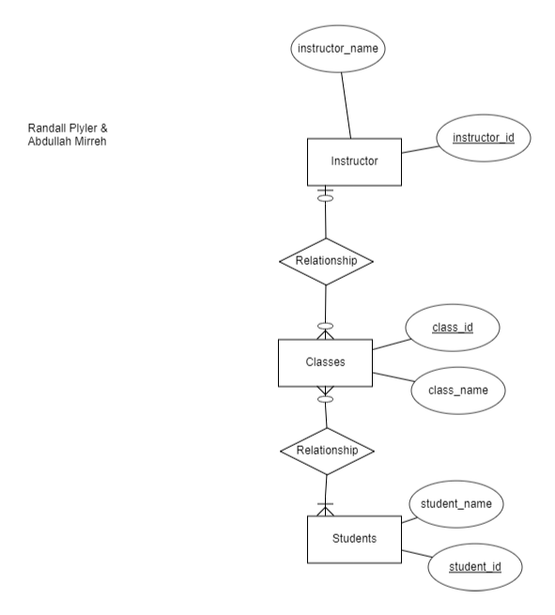

*PART B:* **(10 points)**

*<Paste Relational Schemas in this location>*

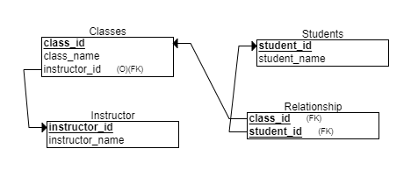

**Scenario 2: The Veterinarian’s Office**

This office houses four vets, one who specializes in large animals and the others in small animals. The veterinarians want to set up a database to track patients (animals), owners, and the associated veterinarian.

Business rules:

* Veterinarians treat numerous patients
* Each patient has a primary-care veterinarian assigned (only one)
* Each veterinarian has at least one but many patients
* A single owner is associated with each patient
* Owners may have numerous number of patients (pets) (one to many)
* Owner data is kept to provide contact information and to facilitate payment of bills

Your goal: to draw a practical ERD to keep track of data requested by the veterinarians. Include primary keys and requested attributes to store data pertaining to the described scenario within an ER model. *Note that you should include at least five additional attributes for each entity in this ERD that you think are relevant to the entity.*

*PART A:* **(10 points)**

*<Paste Entity Relationship Diagrams (ERDs) in this location>*

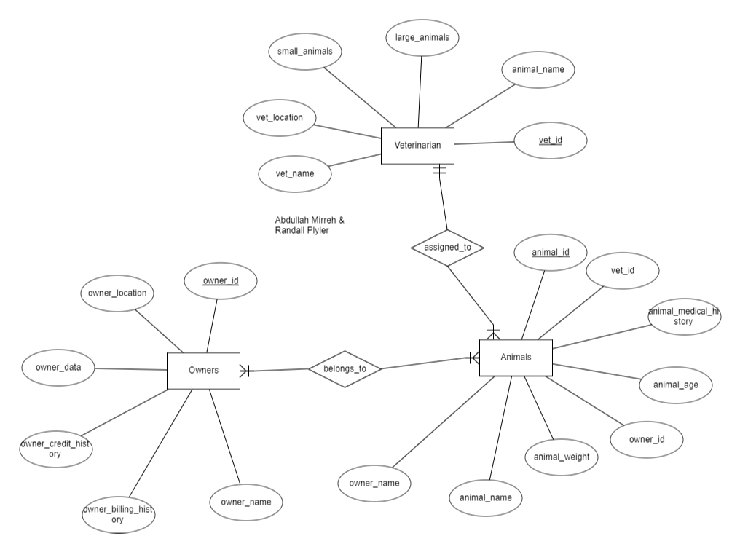

*PART B:* **(10 points)**

*<Paste Relational Schemas in this location>*

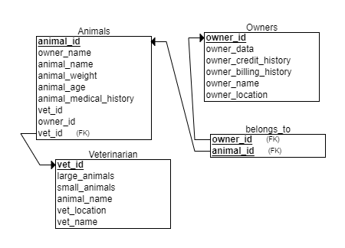

**Scenario 3: Campsite Reservations**

Scout programs are organized around regional districts that each contains numerous troops (a local group of youth and adult members).

Business rules:

* Each troop has numerous members in the form of scouts (youth members) and a variety of leaders (adult members), including Scoutmasters and Assistants
* Leaders are associated with no more than one troop and may temporarily not be associated with a troop
* Troops can't be created without at least one leader but can have many leaders
* Troops can't be created without at least one scouts but can have many scouts
* Scout data can't be entered without a troop assignment (one troop)
* Each district has numerous campsites which can be reserved by a leader and a scout acting together
* Leaders and scouts are able to check out multiple campsites
* Campsite reservations must be able to be identified by data as well as by the leader and scout who made the reservation, and must include data detailing the start date and end date for the reservation. Each reservation needs to have one leader, scout and camp site.
* Define Reservation as a separate entity with it’s own unique id (as an associate entity)

Your goal: to draw a practical ERD to be used by the Arrowhead District to manage troops, leaders, scouts, and campsite reservations in the district.

*PART A:* **(10 points)**

*<Paste ERD in this location>*

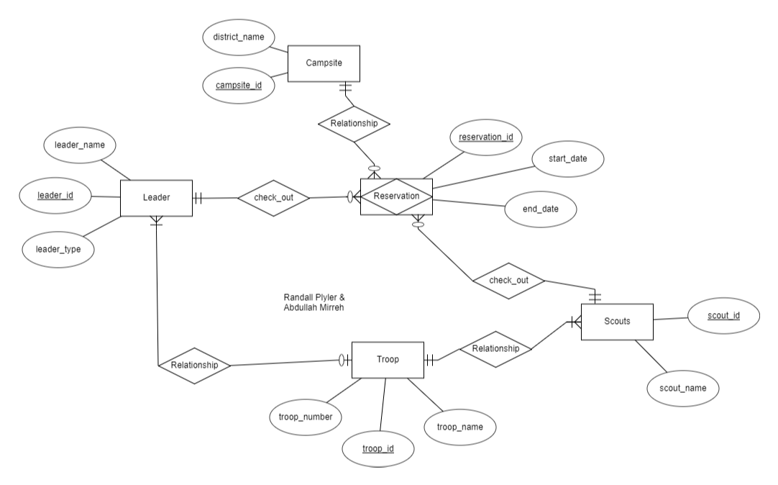

*PART B:* **(10 points)**

*<Paste relational model/schema in this location>*

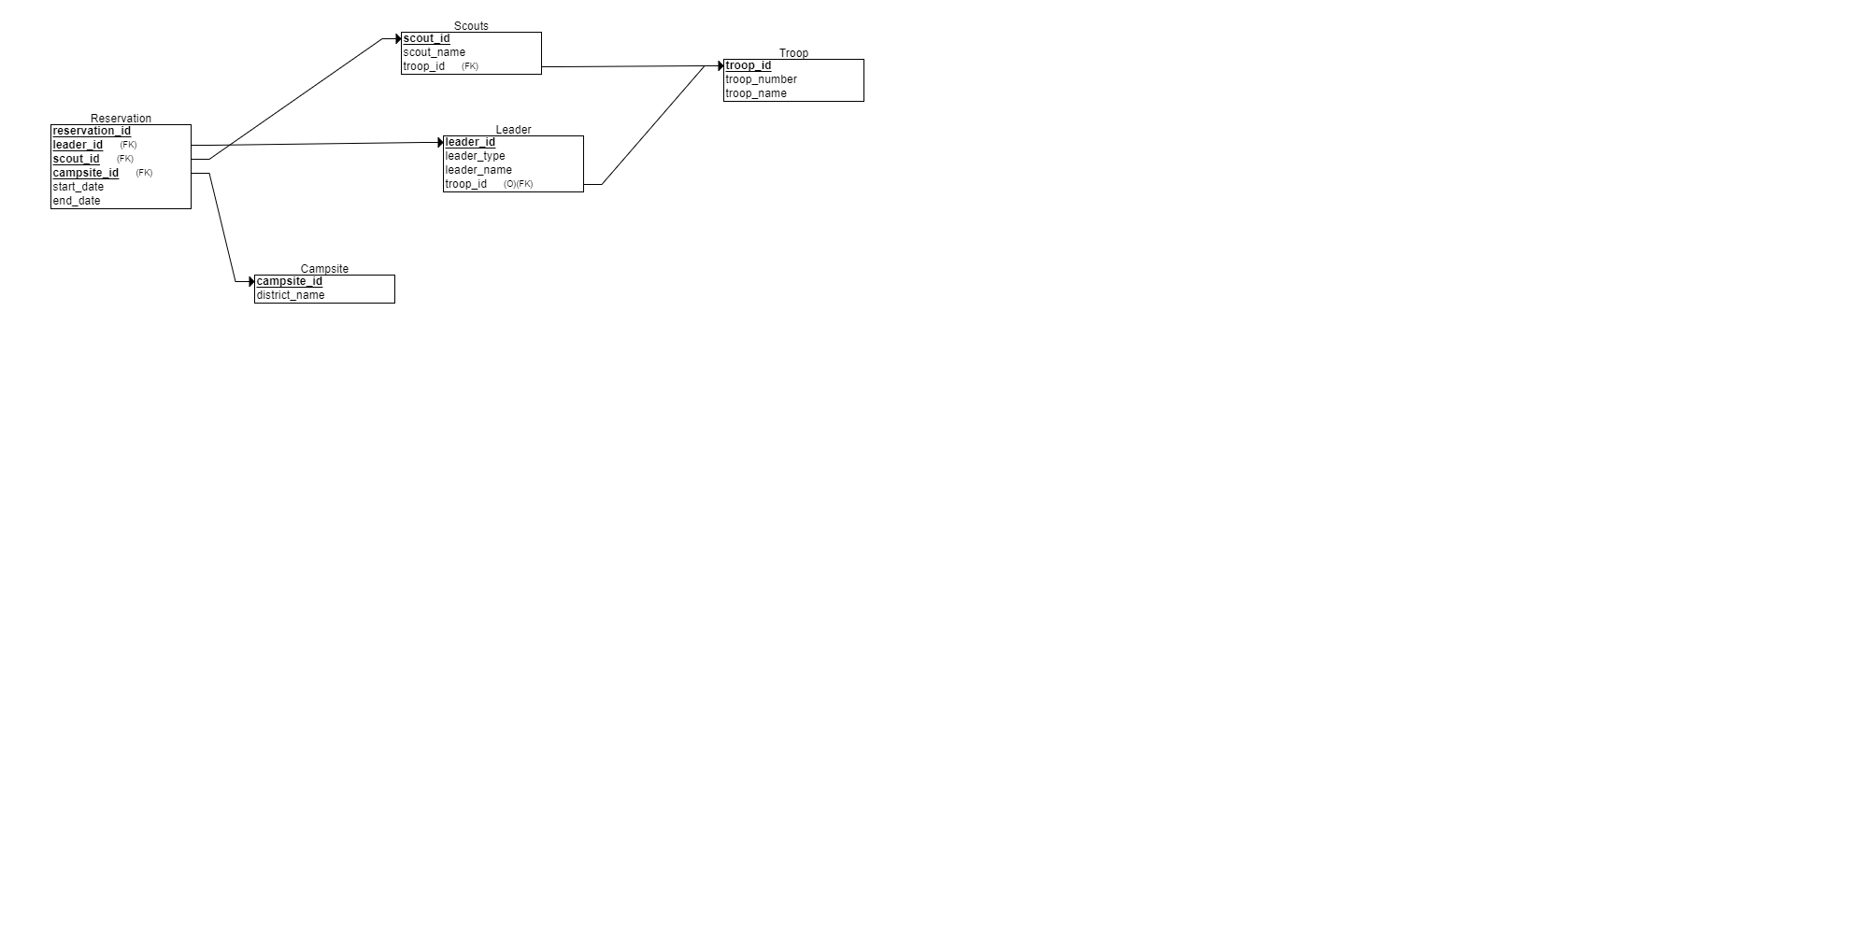

**Scenario 4: Chemists, Projects, and Equipment**

A laboratory employs several chemists (identified by employee ID) who work on one or more projects (identified by project ID). Chemists may use certain kinds of equipment (identified by equipment ID) on each project. The laboratory wishes to record the date when a particular piece of equipment is assigned to a particular chemist working on a particular project. Each chemist must be assigned to at least one project and one equipment item. Equipment and projects do not necessarily have to be assigned before being recorded in the planned system. Develop a practical ERD that can efficiently store data about the entities described in this scenario. Include primary keys and an assignment date attribute in your ERD. Define the ASSIGNMENT as a separate entity (as an associate entity).

*PART A:* **(10 points)**

*<Paste Entity Relationship Diagrams (ERDs) in this location>*

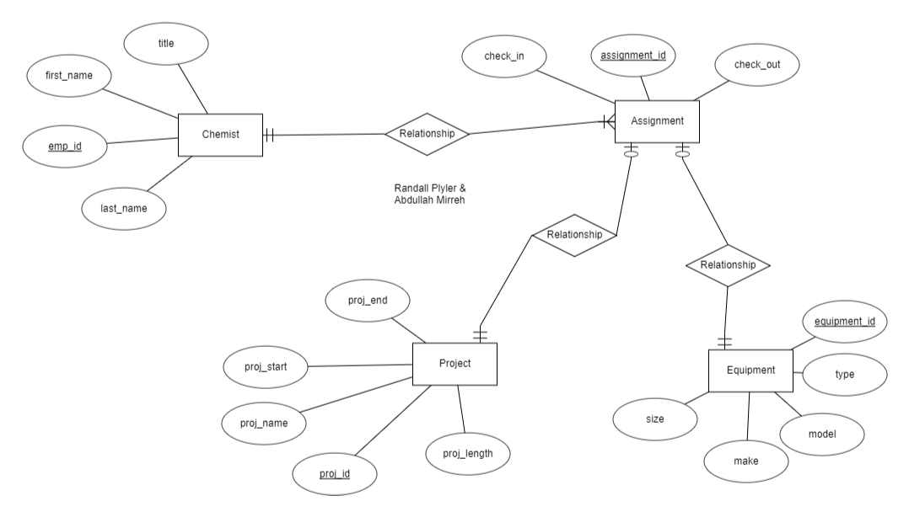

*PART B:* **(10 points)**

*<Paste Relational Schemas in this location>*

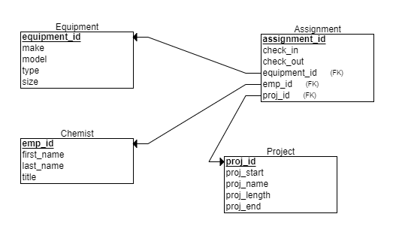

**Scenario 5: Customers and Products**

XYZ Corporation has customers (identified by Customer_ID) who are entered into the system when they place their first order (Order_ID). XYZ sells six different products (Product_ID). Each order has a unique order_id, order date, scheduled transportation date and delivery date. Draw a practical ERD that can store data accurately for XYZ Corporation’s customers, products and orders. Use only the attribute names shown above (Customer_ID, Order_ID, and Product_ID) to provide all primary keys in this ERD. Define the order as an associate entity. Each order has only one customer but one to many products. Products may or may not have orders.

*PART A:* **(10 points)**

*<Paste Entity Relationship Diagrams (ERDs) in this location>*

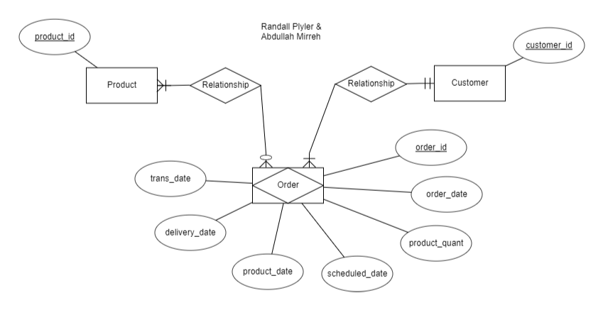

*PART B:* **(10 points)**

*<Paste Relational Schemas in this location>*

